# Startup - Starting up the System the First Time

You can install DreamGrid by downloading and saving InstallDreamGrid.exe in an empty folder and running it.

Or you can install DreamGrid by unzipping the zip file into a new, blank folder.

Then locate and click “Start.exe”. You may get a security warning. All my binary code is digitally signed and is cryptographically verified to protect you and to assure you that the code you get is what is originally authored. It is virus-free and has no ads. It should say "Verified Publisher: Outworldz, LLC”.

Om Server products, you will need to install Microsoft Dot Net 3.5 in “Server Manager”.   
Click Next.. Next… and continue through the Menus on the left, until you see this screen under **Server Roles**.

elect Dot Net 3.5 and select Install.



Click [Start] in the top left of the menu:

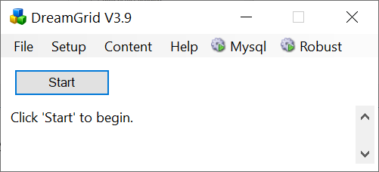

A Robust DOS bxo will appear and create a new Opensim Grid. It should disappear onto the task bar.

This box will appear for you to claim ownership of the Grid. Use a unique, new long password as this is the avatar that owns the grid.

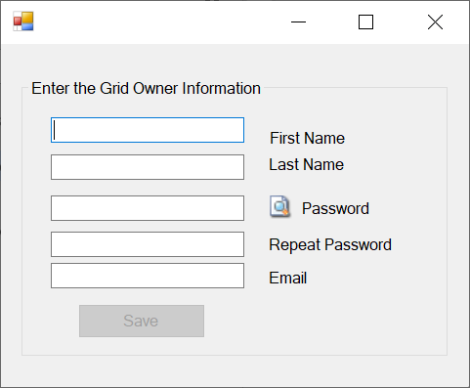

Another DOS box will appear. This will be your first region. The region is named "Welcome".  You can change this name later. The system will ask you for an Estate name.  You can just press enter to name it “My Estate”, or type in a new name. Estates hold regions and the avatar that owns the Estate will own all regions in that Estate.

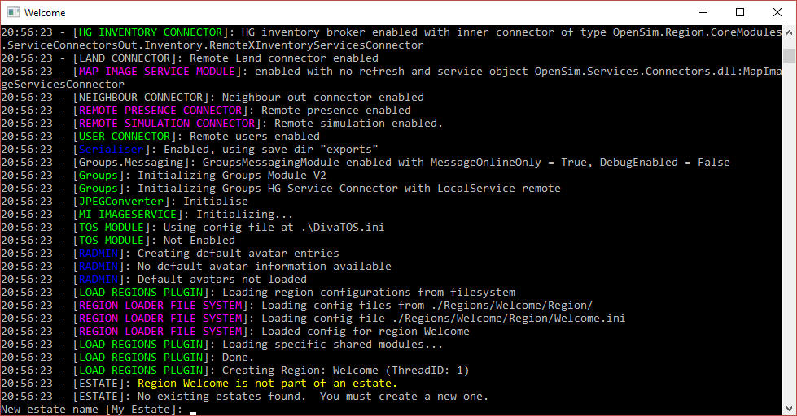

It will then ask you for the owner’s name of this region.   **Use the same name that you first entered.**

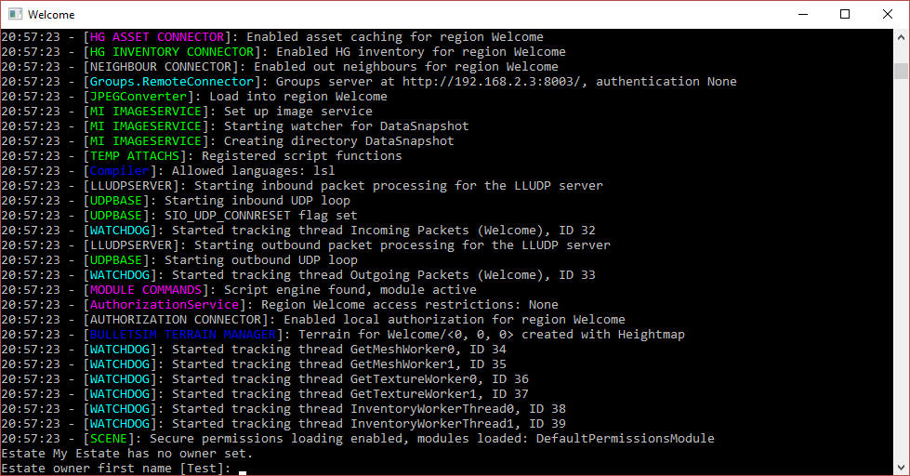

The system will tell you "**INITIALIZATION COMPLETE FOR Welcome - LOGINS ENABLED"**

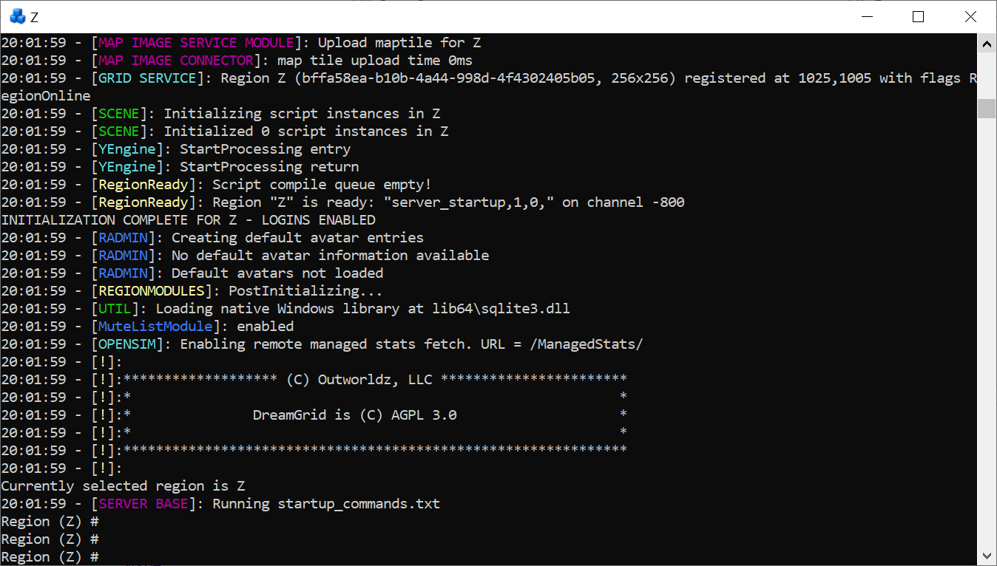

## Grid Address

Click the first item in the Help menu - **Show Grid Address**. It may print a name, or an IP address.



The system will print the address.

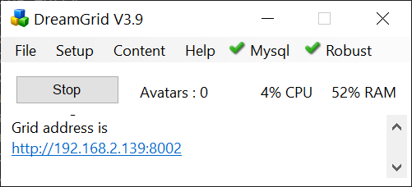

To change this to a domain name, you will need to run some tests. These steps are in the Help manual for Hypergrid Setup. Before you go change thinks, please finish booting up your grid and finish these steps to test it.

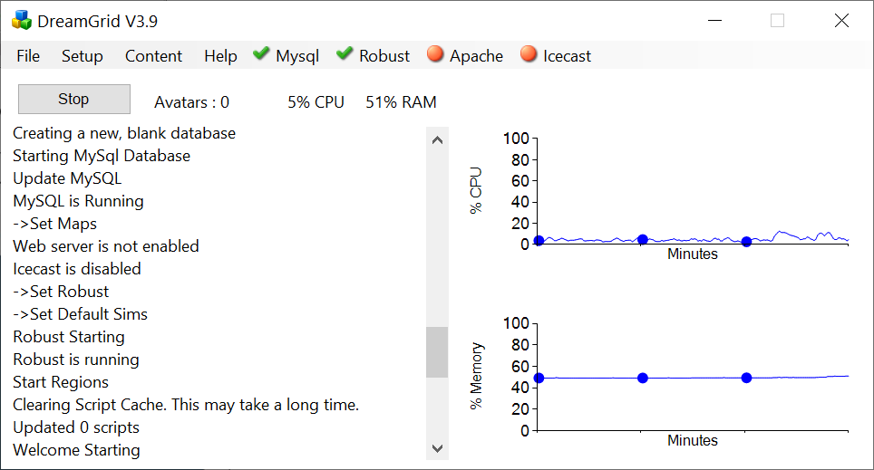

You can drag the borders of the windo to expose graphs on performance other options. Icecast and Apache will be Red as they are disabled as a default. These options let you host a Shoutcas/Icecast server to stream audio into your world, and to run a Web server such as WordPress or Joomla/jOpensim.

## Setup a Viewer

Download the Firestorm viewer for Opensim. You can get it from <https://www.firestormviewer.org/>

Launch the viewer and go to the Viewer Preferences menu (Ctrl-P).

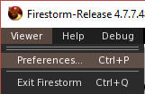

Go to the Opensim Grid manager screen



Add the IP address to the Firestorm or "Add new Grid" field and click "Apply".

You should now be able to select your new DreamGrid in the pulldown login screen and log in with the same First and Last Name and password you originally entered. You should then appear on a small round island.

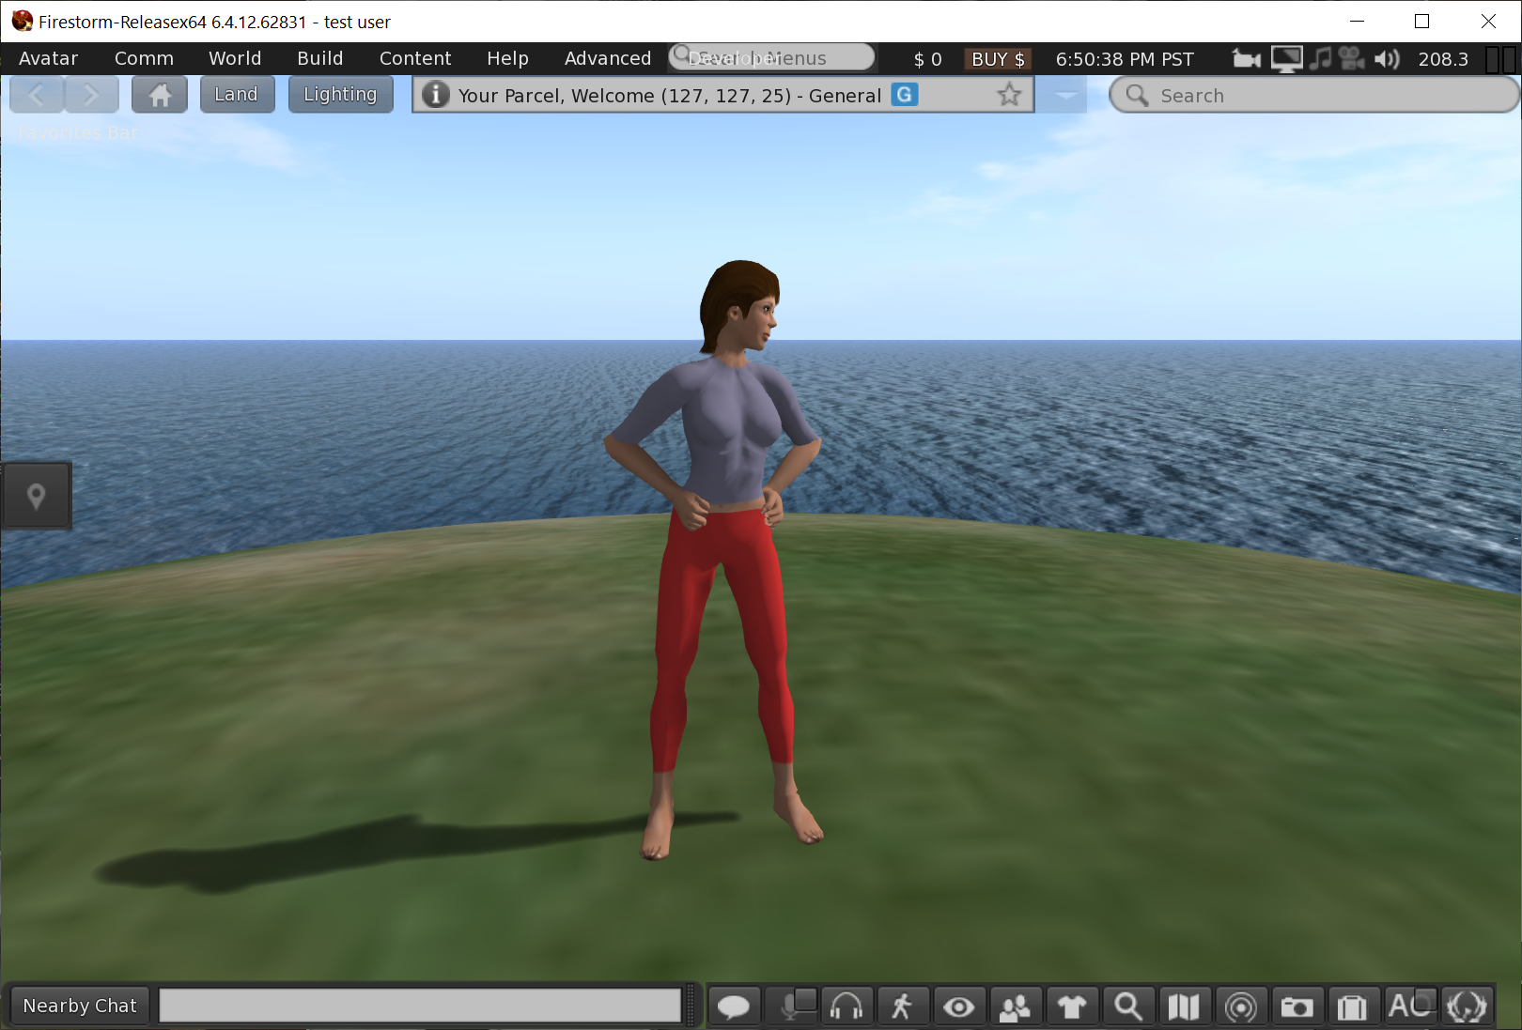

## Useful First Steps

To create a flat island, go to the Welcome region console icon and type in ‘terrain fill 23’ and press enter. You will see the terrain fill to be 3 meters above the water level.

Load an OAR: Go to the first entry in the Content Menu.



Search for ‘island’ and click the Lonely Island (shown at top right here) as it is a fast, quick demo of this capability.



Click the Island and a Choose Region box will pop up. Double click the Welcome Region or click once and select OK.

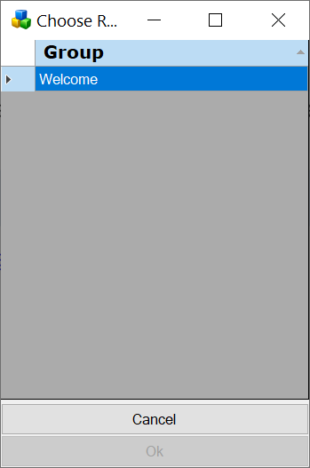

A region options panel will appear:

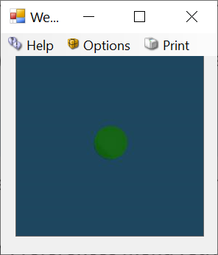

This map shows the original “Pimple Island” where you are standing. There are Options at upper left to allow you to Merge two or mor OARs, or Erase all contents, to Set Terrain, and so on.

For now, just click the Blue Map and the system will load the OAR.

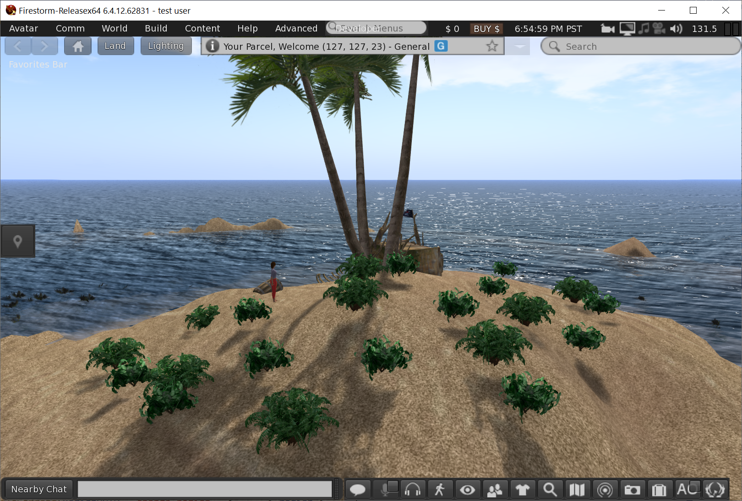

## Other things to look at

To create another user, go to the Robust Console and type ‘create user’ then type enter. You can press Enter for any question you do not understand.

UI: To grant yourself more permissions to edit and add users to the Web Interface, type ‘set login level <First Name> <Last Name> 200’ and press enter.

UI: To view the Web User Interface, look in Help at the section **View Web Interface** (Ctrl + W). The address is also [**http://127.0.0.1:8002**](%20http:/127.0.0.1:8002). You can log in with your Avatars First and Last Name and rename or delete users.